 GDPL Assignment 2 – Report

# Rube Goldberg Machine overview

# By Antonino Frazzitta (s5117080) 2019

Contents

Design and inspiration 1

Implementation choices 2

Devices and sequence 2

Honourable mentions 16

Strengths and points to improve 16

Strengths 16

Where to improve 16

References 16

# Design and inspiration

The Rube Goldberg machine used in the sequence is sci-fi themed and every aspect of it is revolving around the this such device implementation, particle systems, materials and minor props. In order to evaluate the scene immersion even more, it has been used a unity corridor demo that had already the environment set up.

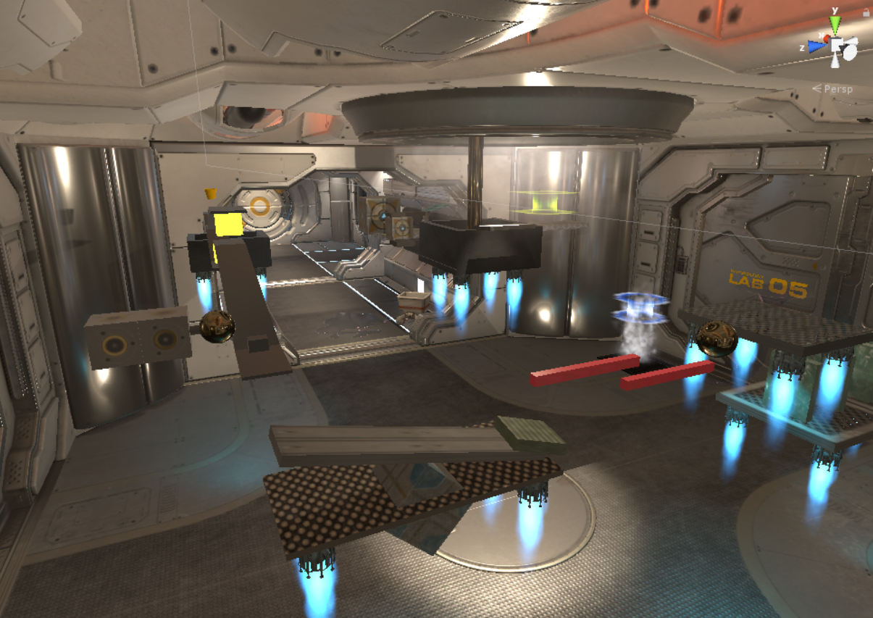

Pic. 1: Main Scene

# Implementation choices

In order to visually and thematically fit the theme, some of the machines they had to have a specific sci-fi feel to theme. This is way there where implemented devices like a gravity changer and a teleport, so the machine wont only has this look but have specific functions related to the theme.

# Difficulties and solution

The toughest difficulty encountered can be identified on the bucket implementation, as rigidbody and mesh collider didn’t cooperate well because it require to be converted to convex, to fix that after several iteration and attempts, it has been applied different box colliders into the bucket mesh to simulate as mush possible its collisions and still work good with the rigidbody.

# Devices and sequence

* **Controllable ball**: The machine starts with the player able to control and move a ball in all directions. Here we can decide to jump into a button that will activate the chain reaction.

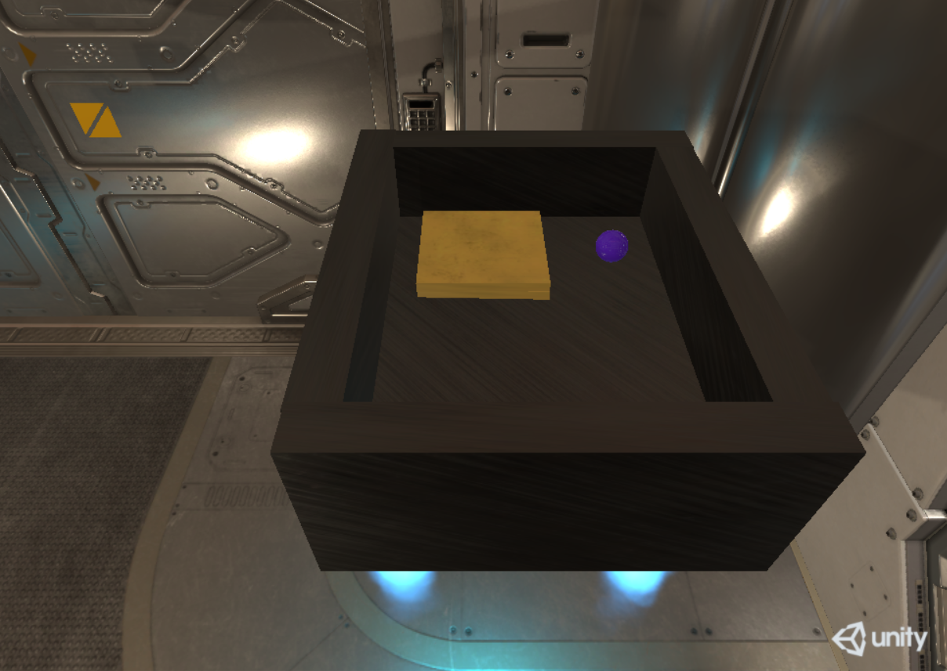

Pic. 2: controllable ball

* **Button:** in this button there is a spring joint that attaches itself into an inferior box. The reaction here is caused by a script checking the position of the object, once the button is set it will trigger the following action.

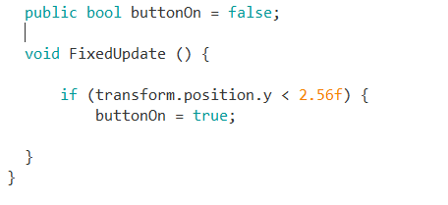

Pic. 3: Button Script.

* **Bucket:** Once activated the script will add a torque on the bucket and make it tilt and unleashing a second ball.

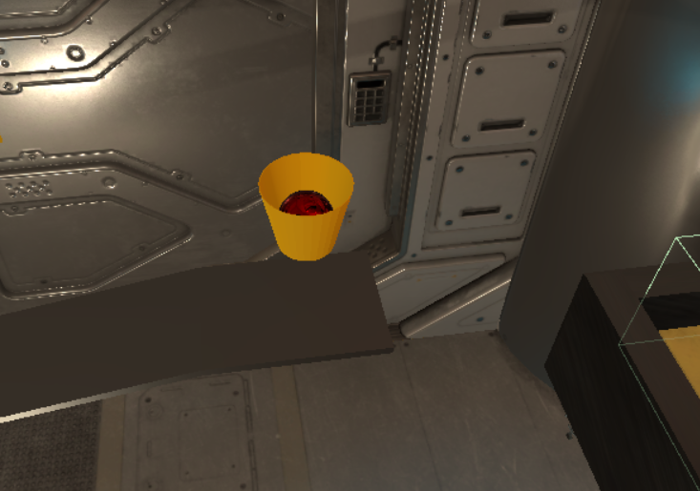

Pic. 4: ball and bucket.

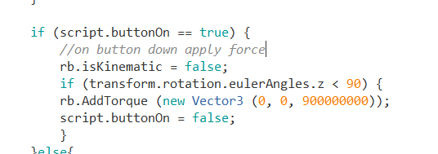

Pic. 5: bucket script.

* **Gravity Changer:** the ball then will get in contact with this yellow trigger. On collision a opposite force of the gravity will be apply in order to make the ball continue.

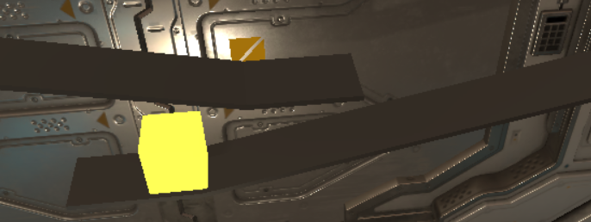

Pic. 6: gravity changer trigger.

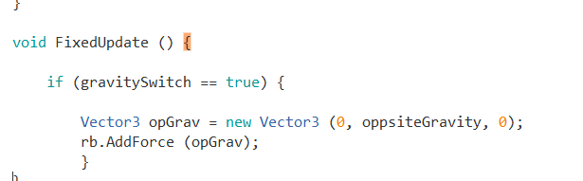

Pic. 7: gravity changer script.

* **Piston:** on front of it there is an invisible trigger that will be activate when the ball collides into it. Once activated it will apply a one directional force and pushing the ball.

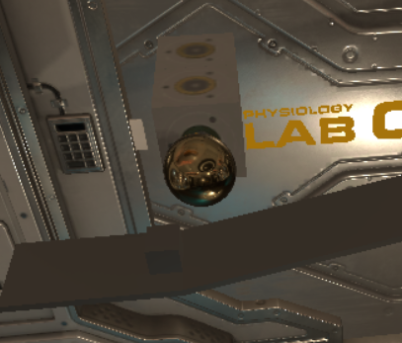

Pic. 8: Piston.

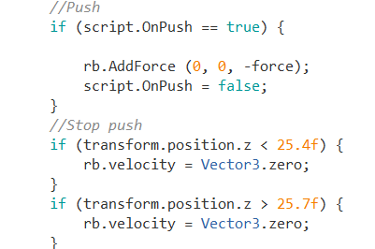

Pic. 9: Piston script.

* **Seesaw:** the ball will fall into a seesaw that has an object on the other side. This will cause the object to move the next object. This device is simply restricted by a hinge joint.

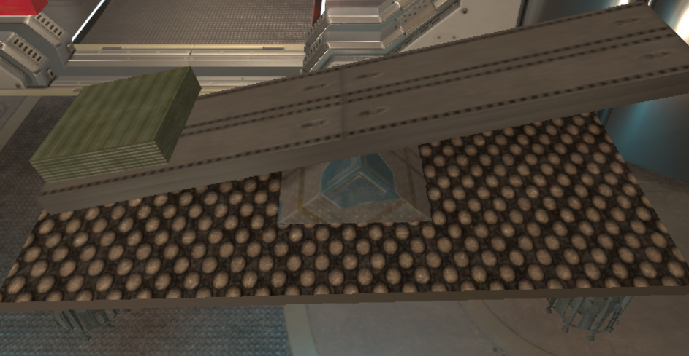

Pic. 10: Seesaw.

* **Spinning sticks:** this sub-sequence is activated by the object thrown by the seesaw. The sticks have a rigidbody component that freeze these into place in all direction apart the x rotation.

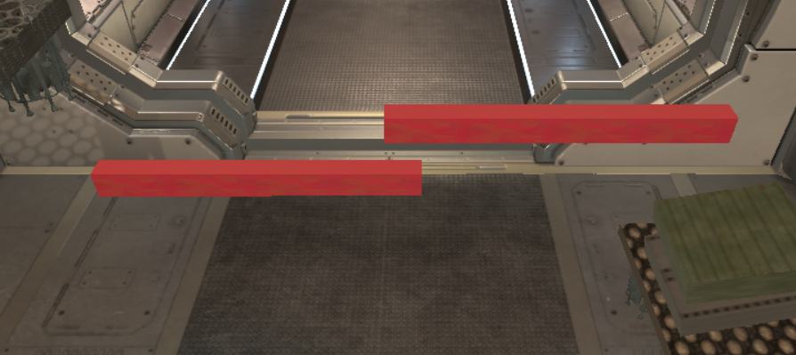

Pic. 11: Spinning sticks.

* **Pendulum:** if a prior stick touches the pendulum this will be activate and start its periodical rotation of 90 degrees by following a mathematical function.

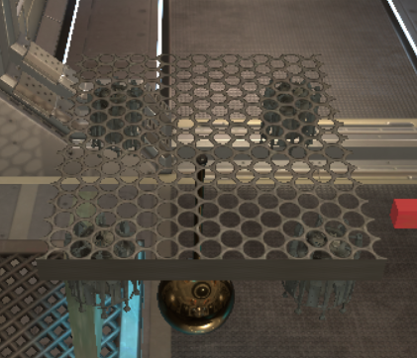

Pic. 12: Pendulum.



* **Domino set:** the pendulum will cause the domino set to fall in sequence, and when the last domino piece collides with button at the end it will communicate with the next piece.

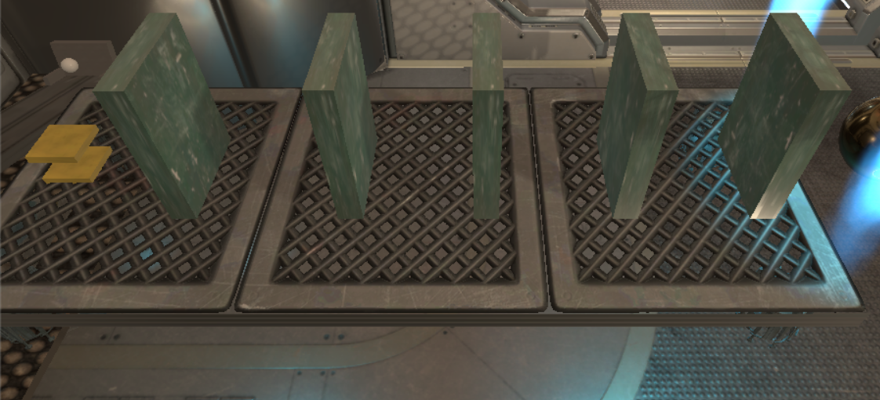

Pic. 13: Domino set.

* **Catapult:** when the variable is set to true a torque will be applied to the catapult and cause it to launch the ball. The catapult bar is hold in place that in same way as the seesaw.

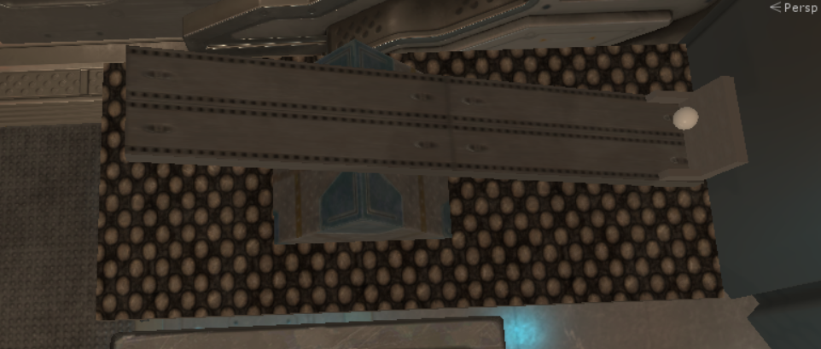

Pic. 14: Catapult.

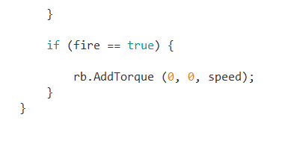

Pic. 15: Catapult script.

* **Funnel:** the ball will fall into a funnel and then end up to the next device.

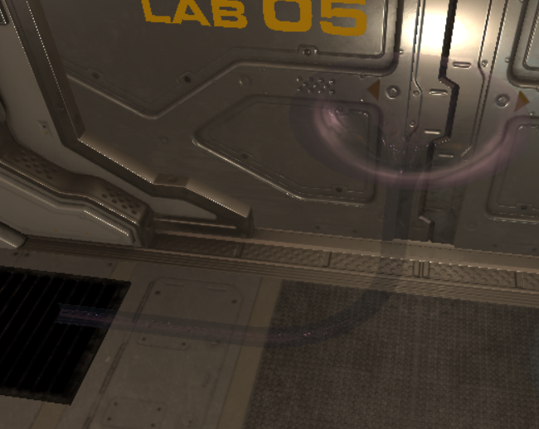

Pic. 16: Funnel.

* **Vent:** on collision happening,this device will apply a force and make the ball levitate and meet the next device.

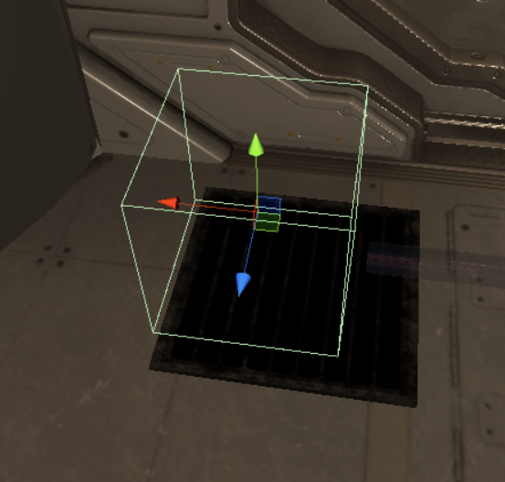

Pic. 17: Vent.

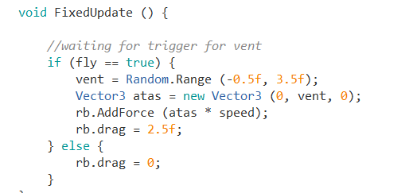

Pic. 18: Fly script.

* **Teleport:** once the collision is detected with ball will send the ball into a new position that is referenced by an empty object placed into a different position.

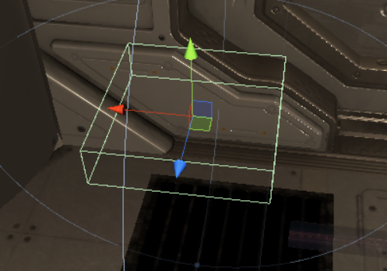

Pic. 18: Teleport Sender.

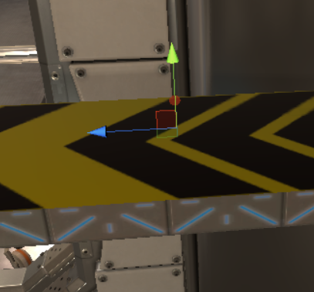

Pic. 19: Teleport Receiver.

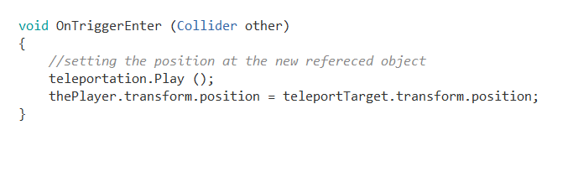

Pic. 20: Teleport Script.

* **Dash Platform:** the ball then will be dropped into this dash pad that will add a force on the z axis right on collision by shooting the ball further.

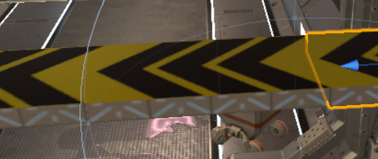

Pic. 21: Dash pad.

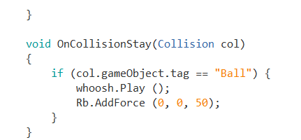

Pic. 22: Dash pad script.

* **Chained Boxes:** the ball will hit the big box present in the platform, and it will make it fall, as it is chained to the smaller one this will cause to drag the last one and it will unblock the next device. The link is made by small capsule objects that uses the hinge joint component.

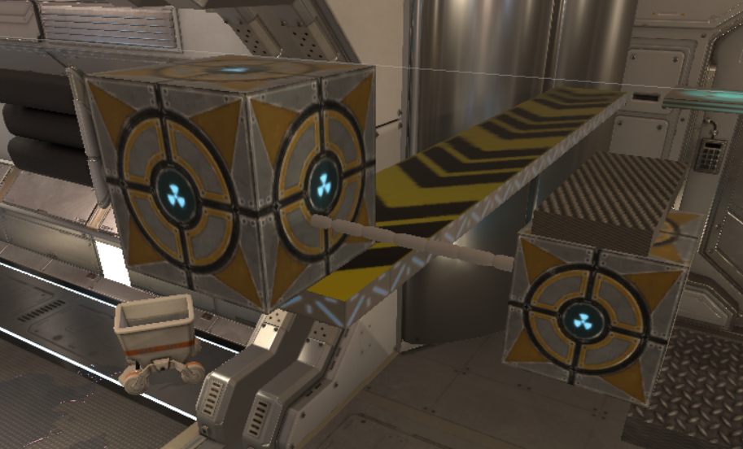

Pic. 23: Chained boxes.

* **Spinner:** this device is simply and object with a script that execute the rotation on update, so it is constantly trying to move event before the reaction.

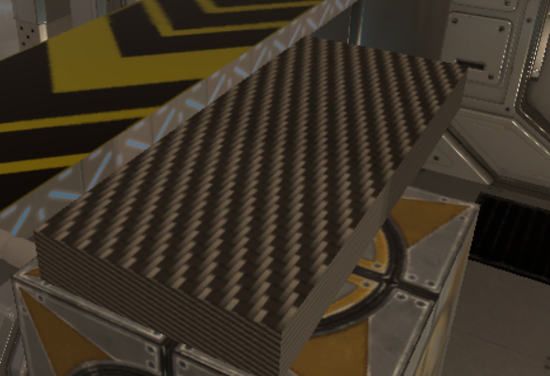

Pic. 24: Spinner.

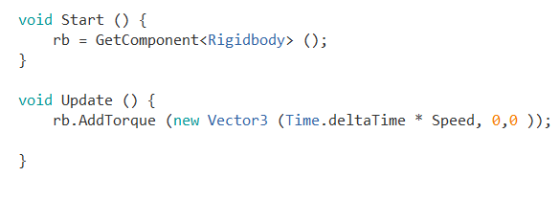

Pic. 24: Rotation Script.

* **Spawner Spring:** once the rotation is unleashed the spinner from before will hit the spring and every collision will make a ball instance to spawn into the next platform.

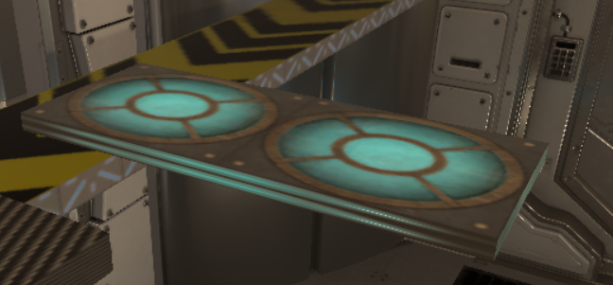

Pic. 24:Spawner Spring.

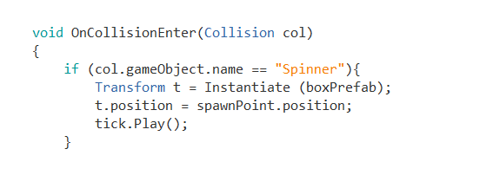

Pic. 24:Spawner script.

* **Last Platform, counter and exploder:** in this sub-sequence the balls are going to be dropped into the platform, this will raise a counter, when the counter arrives to 20 an explosion force will be applied, and the platform will fall as the floater script is disabled.

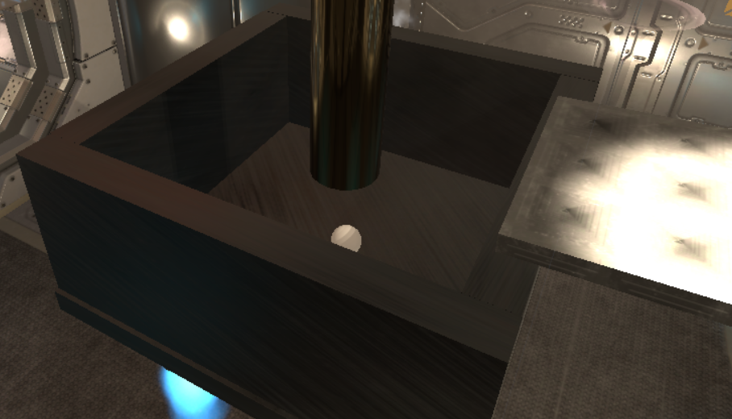

Pic. 25:Last platform.

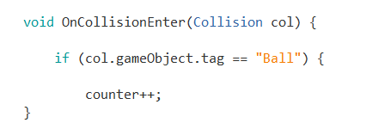

Pic. 26:Counter process.

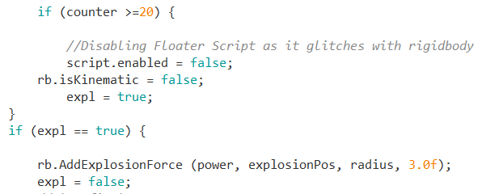

Pic. 27:Counter exploding process.

* **End Banner:** once the platform has fallen off the end banner which is fixated in place by and hinge joint will be able to fall and rotate, this will revel the end banner message.

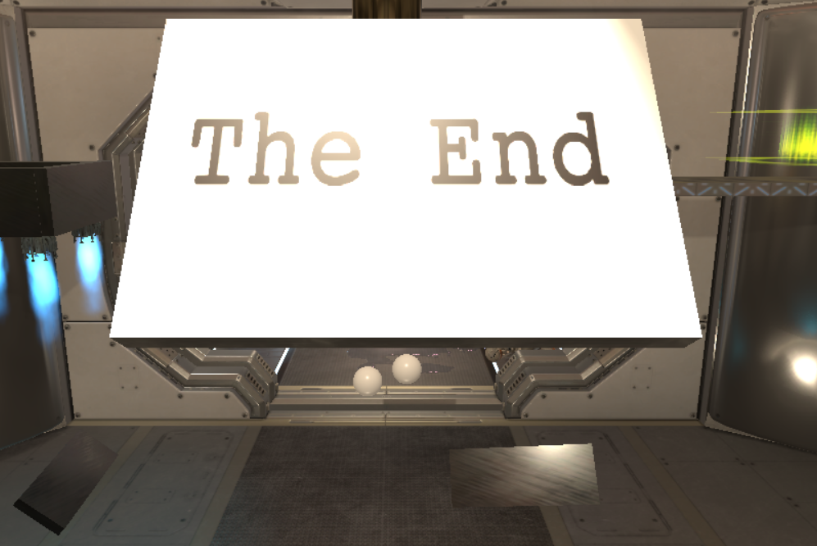

Pic. 27:the end banner.

* **Pause menu:**  after the sequence we can assist at the pause menu that is triggered at the finish of the cinematic here the time is frozen, and the music is stopped, and we are able to restart the sequence or go back to the title screen.

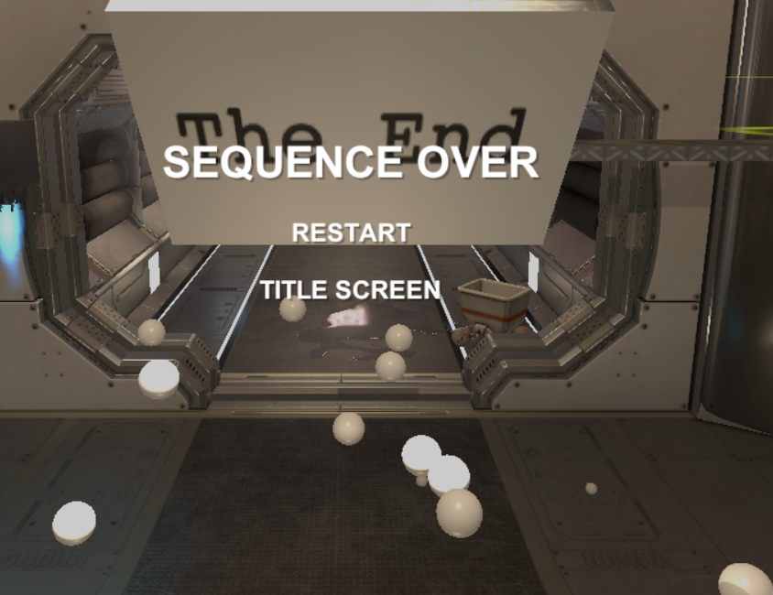

Pic. 28:pause screen.

# Honourable mentions

* **Pitch changer script**: for the ball movement there was implemented a script that changes the roll pitch for the balls used.

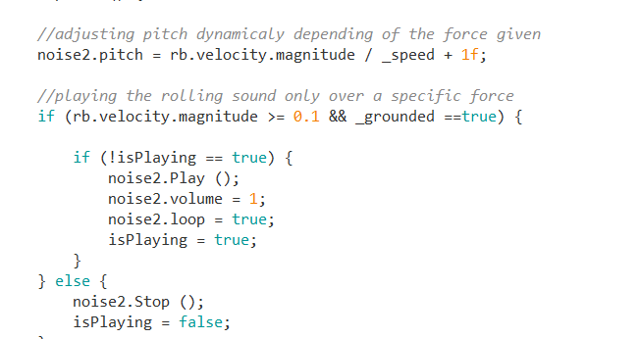

Pic. 29:Roll script.

# Strengths and points to improve

## Strengths

* Immediate reaction and collision detection for the devices.
* Themed machine with fitting devices for the theme.
* Strongly physics driven.
* Scripts communication.

## Where to improve

* Adding a physic fluid instead of the balls of the ending part.
* Better scripting and animation management on the reversing of the first camera animation.
* Adding an initial animation on the start sequence (Appearing of the ball).
* Change the vent implementation in the machine to show the simulation of the wind and floating effect given to the ball.

# References

Unity Technologies, 2015, Corridor Lighting Example [Showcase], Available From: <https://assetstore.unity.com/packages/essentials/tutorial-projects/corridor-lighting-example-33630>, [Accessed: 26/4/2019]

M31, 2016, TELEPORTER[Prefab], Available From: <https://assetstore.unity.com/packages/vfx/particles/teleporter-25645>, [Accessed: 03/5/2019]

Nobiax / Yughues,2013, Yughues Free Metal Materials [Materials] , Available From: <https://assetstore.unity.com/packages/2d/textures-materials/metals/yughues-free-metal-materials-12949>, [Accessed: 03/5/2019]

Unity Technologies, 2018, ProBuilder 2.x [Tool], Available From: <https://assetstore.unity.com/packages/tools/modeling/probuilder-2-x-111418>, [Accessed: 04/5/2019]

Unity Technologies, 2016, Unity Particle Pack 5.x [Particle effects], Available From: <https://assetstore.unity.com/packages/essentials/asset-packs/unity-particle-pack-5-x-73777>, [Accessed: 04/5/2019]

BLUEWARM Digital Multimedia,2017, Space_Objects [Prefabs], Available From: <https://assetstore.unity.com/packages/3d/props/space-objects-91874>, [Accessed: 04/5/2019]

Unity Technologies, 2017, TextMesh Pro [Tool], Available From: <https://assetstore.unity.com/packages/essentials/beta-projects/textmesh-pro-84126>, [Accessed: 10/5/2019]

Kyle Gates,2014, Rube Goldberg Machine [3D models], Available From: <https://3dwarehouse.sketchup.com/model/fecafd17224f649d1539cf3d32b88d8a/Rube-Goldberg-Machine>, [Accessed: 01/5/2019]

Amelia Wattenberger: US, arrows [Image], Available From: <https://thenounproject.com/term/arrows/11176/>, [Accessed: 10/5/2019]

adcbicycle, 2006, 7.wav [Sound], Available From: <https://freesound.org/people/adcbicycle/sounds/14060/>, [Accessed: 11/5/2019]

Claire.H, 2013, stone_mechanisem_loop_02.wav, Available From: <https://freesound.org/people/Claire.H/sounds/182344/>, [Accessed: 11/5/2019]

Newagesoup,2016, FUN-EXPLOSION04.wav, Available From: <https://freesound.org/people/newagesoup/sounds/347317/>, [Accessed: 11/5/2019]

Leszek_Szary,2012, teleport, Available From: <https://freesound.org/people/Leszek_Szary/sounds/172206/>, [Accessed: 11/5/2019]

XxChr0nosxX, 2015, Woosh 1.mp3, Available From: <https://freesound.org/people/XxChr0nosxX/sounds/268225/> [Accessed: 11/5/2019]

Nebyoolae,2014, Vent Noise 01, Available From: <https://freesound.org/people/nebyoolae/sounds/250282/>, [Accessed: 11/5/2019]

InspectorJ,2017, Alto Gong, Metal Hit, B (H6 XY).wav, Available From: <https://freesound.org/people/InspectorJ/sounds/411574/>, [Accessed: 11/5/2019]

OGsoundFX,2018, Guns & Explosions Album - Bullet Impact 21.wav, Available From: <https://freesound.org/people/OGsoundFX/sounds/423106/>, [Accessed: 11/5/2019]

Zgump, 2009, Reverse Bass 01.wav, Available From: <https://freesound.org/people/zgump/sounds/85056/>, [Accessed: 11/5/2019]

Jagadamba,2014, Clock Tick, Available From: <https://freesound.org/people/Jagadamba/sounds/254315/>, [Accessed: 11/5/2019]

Coobek, 2013, Metal tick 4, Available From: <https://freesound.org/people/coobek/sounds/185608/>, [Accessed: 11/5/2019]

Magixmusic, 2013, hallelujah, Available From: <https://freesound.org/people/magixmusic/sounds/187470/>, [Accessed: 11/5/2019]

2imitk, 2015, Air Steam Various short 01, Available From: <https://freesound.org/people/2imitk/sounds/279044/>, [Accessed: 12/5/2019]

VSokorelos,2016, Sliding Lock.wav, Available From: [https://freesound.org/people/VSokorelos/sounds/346180/#](https://freesound.org/people/VSokorelos/sounds/346180/), [Accessed: 12/5/2019]

Isteak, 2018, Enter Button - Low Robotic, Available From: <https://freesound.org/people/isteak/sounds/442161/>, [Accessed: 12/5/2019]

ZenithInfinitiveStudios,2016, UI_button1.wav, Available From: <https://freesound.org/people/ZenithInfinitiveStudios/sounds/343015/> [Accessed: 12/5/2019]

KieranKeegan, 2018, UI back sound, Available From: <https://freesound.org/people/KieranKeegan/sounds/418231/> [Accessed: 12/5/2019]

Levelclearer, 2016, solar939.wav, Available From: <https://freesound.org/people/levelclearer/sounds/344881/> [Accessed: 12/5/2019]

Donovan Keith,2016, Floater [Script], Available From: <http://www.donovankeith.com/2016/05/making-objects-float-up-down-in-unity/>, [Accessed: 5/5/2019] – used to make the platforms have a floating effect